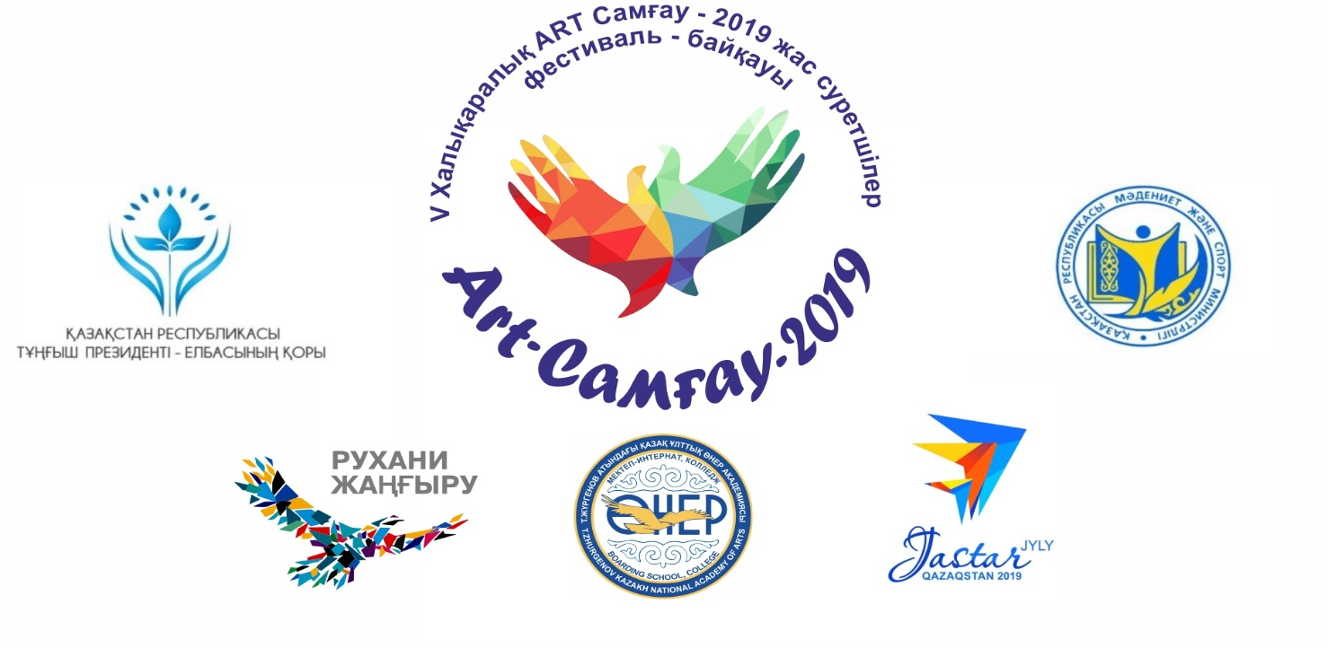

MINISTRY OF CULTURE AND SPORTS OF THE REPUBLIC OF KAZAKHSTAN
T. K. ZHURGENOV KAZAKH NATIONAL ACADEMY OF ARTS,
COLLEGE

Provision of the
V International festival - biennial of young artists “A R T – Samgau – 2019”
among colleges of art dedicated to the 115th anniversary of the People's artist of Kazakhstan, the founder of the Kazakh fine art Abylkhan Kasteev
4 - 9 October 2019.

- General provision

V International Festival - Biennale of Young Artists "ART - Samgau-2019" for colleges of Art, conducted in the framework programs of the Elbasy of the Republic of Kazakhstan "Bolashakka Bagdar: Ruhani zhangyru", "Seven faces of the great steppe" and 2019 - The year of youth, dedicated to the 115th anniversary of the People's artist of the Kazakh SSR, the founder of the Kazakh fine art Abylkhan Kasteev, in order to support artistic creativity, promote and establish mutual understanding and international communication of students of art colleges with their peers from around the world, identify new talents, create additional conditions for improving the professional skills of young lovers of painting and decorative arts, as well as for the development of intellectual level, increasing their interest in national and world history and culture.
The organizers of the Festival-contest are the College of the Kazakh national Academy of arts named after T. Zhurgenov, with the support of the Fund of the First President of the Republic of Kazakhstan – the Leader of the Nation, the Ministry of culture and sports of the Republic of Kazakhstan, the Kazakhstan national Federation of UNESCO Clubs, the Union of artists of the Republic of Kazakhstan, Akimat of Bostandyk district of Almaty.
Ceremonial opening and closing exhibition of the V International Biennial Festival of Young Artists "ART - Samgau-2019" scheduled to host at the exhibition hall of the Fund of the First President of the Republic of Kazakhstan - Leader of the Nation.
Within the framework of the festival-contest "ART - Samgau-2019" it is planned to hold a scientific and practical conference, round tables on topical issues of education in the field of culture and art, master classes with the participation of professors, prominent artists of Kazakhstan and representatives of foreign delegations-participants. At the end of the certificates are awarded the national educational and methodical Association of professional development, as well as planned cultural program, excursions, concerts.

2. Aims and objectives
Aims:
- to show the cultural and historical heritage of Kazakhstan;
- development of natural differences and wealth of Kazakhstan;
- to discover traditions of other landscape schools;
- to develop and strengthen friendly, cultural and creative ties between young artists from different countries;
- Sharing with experiences and achievements of gifted children and youth - participants from different countries;
- Strengthening and establishment of international relations and cooperation through cultural and creative exchange;
- identify and promotion young talented painters;
- to create conditions for creative communication.

Objectives:
- Popularization of the image of the Republic of Kazakhstan;
- Implementation of complex measures on patriotic education;
- Formation of civil activity;
- The disclosure of the creative potential of young painters;
- Consolidation of culture and education workers and creative teachers;
- Support for the national traditions and culture, education of morality and ethics, inter-ethnic harmony and tolerance;
- to see the cultures of different countries.

3. Nominations
PLEIN

- landscape / 1 creative work /;
- still-life with apples Almaty-Aport/ 1 creative work /;
Methods of execution: painting and drawing.
- Urban architectural landscape / 1 creative work /
- Technique: Oil, gouache, acrylic (optional).

4. Jury
The concurs evaluates by an independent jury, composed of well-deserved invited painters, famous fine art experts, art historians, teachers of art schools and 1 representative of the participating delegations can be chosen as an expert by carrying out a toss.
The jury has the right: to divide the medal place, not to award all medal places, to award special prizes.
The decision of jury is final and not subject to change.

5. Evaluation criteria
- singularity of design;
- artistic mastery level of the authors;
- originality of performing creative tasks, the work must be completed

6. Prizes and awards
V International Festival - Biennale of Young Artists "ART - Samgau-2019" will award participants on the basis of "Grand Prix" competition with І, ІІ,ІІІ place diplomas.
Participants are awarded with memorable gifts, appreciation letters will be given for teachers and sponsors. Festival Organizing Committee established special prizes.
"Grand Prix" and winner diploma will be given for absolute winners of the Festival-Biennale.

7. Organizational and technical requirements
1. Participants should send application with the seal and personal photo with size 3.5х4.5 cm (scan.copy) and 1 work on each nomination (1 work on landscape and still life, size 40cм х 50cм), (1 work on Urban architectural landscape) to artsamgau17@gmail.com; e_liza@list.ru Deadline: 10th of June 2019.
2. Heads of participants, the teachers are planning carrying out workshops; have to indicate in form the theme of workshops on nomination till 10 June 2019. All required materials in order to carry out the workshops: tools, visual-methodical manual etc.
Drawings are signed as follows:
Last name/first name of the artist (painter), age, city, state, header / Last name, first name/, are also transferred to the Organizing committee.

8. Participation conditions
¬ Accommodation, 3 meals a day at the expense of the organizers of the Festival-competition.
¬ Round trip, visa expenses, insurance at the expense of participants.
¬ The registration fee.
In a festival-biennale can take part in the students of colleges of arts (age of 16-19 years), from each educational institution 1 header - the leading teacher and 5 participants.
For participants who passed selection round, the cost of participation (per group)
in a festival is:
- for residents of the Republic of Kazakhstan– 100 euro (in tenge - at the exchange rate of the National Bank of the Republic of Kazakhstan).
- for participants from neighbouring countries and beyond - 100 euro (in tenge - at the exchange rate of the National Bank of the Republic of Kazakhstan).
Into an organizational contribution enters:
- transfer;
- organization of exhibitions;
- city tours, visiting museums, a concert program.
Return fare is at participants’ expenses.
Payment of a contribution is made no later than day of arrival in the festival- biennale Staff.
The works which received prize-winning places, do not come back and remain in festival Fund.
To participate in the exhibition, participants present their work in the day of arrival.
Evaluation of participants' works is made by closed vote of the jury.

9. Terms and venue

«АRT - Samgau - 2019» The V International Festival festival- biennale young artists among college of arts will pass from 04.10.2019. till 09.10.2019 in the city of Almaty.
Check 04.10.2019 years before 10.00 hours (local time).
Departure 09.10.2019 years (from 15:00 hours.).

MINISTRY OF CULTURE AND SPORTS OF THE REPUBLIC OF KAZAKHSTAN
T. K. ZHURGENOV KAZAKH NATIONAL ACADEMY OF ARTS,
COLLEGE

The festival program

Day 1. 04.10.2019
09.00. Arrival of participants, registration and accommodation of participants and guests. Meeting with group leaders.
13:00 -14:00. Lunch Time.
14:00 – 15:30. Workshops.
17:00.-18:30. Ceremonial opening of the festival and the exhibition of works of participants / Foundation of the First President of the Republic of Kazakhstan, the Leader of the Nation/.
19:00. Dinner. Acquaintance party - entertaining show among friends.

Day 2. 05.10.2019
8:00 - 8:30. Breakfast
9:00 - 10:30. Plein-air/ Alma-Arasan gorge/.
13:00 -14:00. Lunch Time.
14:30-17: 00. Plein-air/ Alma-Arasan gorge/.
18:30. Dinner.

Day 3. 06.10.2019
8:00 - 8:30. Breakfast
9: 00-12: 30. Plein air, in the nomination "still Life with Almaty apples-aports" /Park of the First President of the Republic of Kazakhstan/.
13:00 -14: 00. Lunch.
14:30-17: 00. Plein air, in the nomination "still Life with Almaty apples-aports" /Park of the First President of the Republic of Kazakhstan/.
18: 30. Supper

Day 4. 07.10.2019.
8:00 - 8:30. Breakfast
10: 00-12: 30. Plein air, in the nomination " urban architectural landscape "/Almaty"Arbat"/.
13:00 -14: 00. Lunch.
14:30-17: 00. Plein air, in the nomination " urban architectural landscape "/Almaty"Arbat"/.
18: 30. Supper

Day 5. 08.10.2019.
8:00 - 8:30. Breakfast
9: 00-12: 30. Visit to the Museum of folk instruments of Almaty.
Visit the exhibition in the main building of the Academy named.after T. Zhurgenov and the Master class.
13:00 -14: 00. Lunch.
15:30-18: 00. Visit to The State.Museum of the arts named after A. Kasteyev. Almaty.
18: 30. Supper

Day 6. 09.10.2019
8:00 - 8:30. Breakfast
9:00 - 12:00. Free time.
12: 00-13: 30. Final plein air exhibition. Closing ceremony of the festival. Awarding of the winners and participants of the festival.
13: 30 -15: 00. Lunch.
Leaving home.

Appendix № 1

MINISTRY OF CULTURE AND SPORTS OF THE REPUBLIC OF KAZAKHSTAN
T. K. ZHURGENOV KAZAKH NATIONAL ACADEMY OF ARTS,
COLLEGE

Application form
The V International festival - biennial of young artists “ART – Samgau – 2019”
among college of arts dedicated to the 115th anniversary of the People's artist of Kazakhstan, the founder of the Kazakh fine art Abylkhan Kasteev
4 - 9 October 2019.

Organization __________________________________________________________________________________
Full address (city, ZIP code)____________________________________________
Phone _____________________________________________________________________________________
e-mail: ________________________________________________________________________________________
Short information of participant _______________________________________________________________

_____________________________________________________________________________________________
List participants (Application is enclosed with).

Leader (teacher) ____________________________________________

Address of organizing committee:
The Republic of Kazakhstan, city Almaty
www.college.kaznai.kz
Street Kablukov 133, phone/fax 8 727- 395-12-48
Cell:8 707 116 27 91, 8 702 352 95 47, 8-705 335 77 33
e-mail: art-samgau@mail.ru; e_liza@list .ru

